Proteus - the world’s first Arbitrary Waveform Transceiver
The new Proteus series of arbitrary waveform transceivers combine the ability to transmit, receive and perform digital signal processing in a single instrument

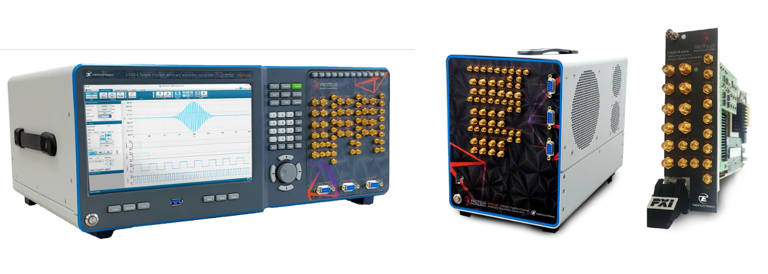
Nesher, August 2020 – Tabor Electronics announces its All-New Proteus - Arbitrary Waveform Transceiver Series product line. The Proteus is a valuable tool for R&D labs in growing markets such as quantum physics, medicine, aerospace and defense, telecommunications and automotive.
For synchronized, phase coherent, multi-channel applications such as quantum physics and radar applications the Proteus arbitrary waveform transceiver is an ideal, space efficient and cost effective solution.
Aerospace engineers will be able to perform real time data streaming and fast feedback loops with an environment dependent waveform generation. A four channel Proteus P2584M for example could emulate four independent high-resolution targets pulses to test the AI algorithm – as it’s an AWG it could also emulate FMCW modulation as well.
In communication new transmission standards that fuel the next generation of connectivity, such as 5G, WiFi-6 and UWB, all rely on utilizing significant amounts of spectral bandwidth. A 9GS/s Proteus is an ideal instrument for generating wideband signals up to 9GHz. With a sampling rate of 9GS/s and a Bandwidth of 9GHz - it allows the instrument to generate signals in multiple Nyquist Zones with very wide bandwidths.

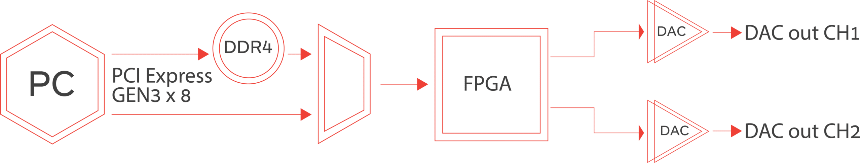Leading Features:
- Dual, Four, eight or twelve channel 9GS/s 16 bit AWG / AWT configurations
- 5.4GS/s, 9GHz Bandwidth, 12-bit digitizer option for a complete arbitrary waveform transceiver system
- Integrated NCO for digital up-converting to microwave frequencies
- Excellent phase noise and spurious performance
- Feedback control system for conditional waveform generation
- Modular PXI Express platform, easily scalable to hundreds of channels.
- High speed PCIe GEN3 x8 lanes communication interface
- Up to 16GS/s waveform memory with the ability to simultaneously generate and download waveforms
- Real time data streaming directly to the FPGA for continuous and infinite waveform generation
- User customizable FPGA for demodulation, digital filtering and application specific solutions
- Innovative task oriented sequence programming for maximum flexibility to generate any imaginable scenario

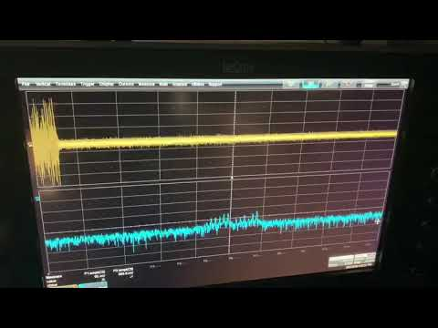
Real Time Record and Playback 2.5GHz Bandwidth_Tabor Proteus AWG.

Jonathan Netzer Tabor’s product director commented: “When we first started planning our next generation of products, we knew we needed to create a flexible and customizable platform that will solve even the most demanding applications. The result exceeded even our own expectations. The Proteus series is no longer just a generator but a fully integrated system of generator and digitizer. Combined with the most advanced technology, industry leading performance and cost-effective platform, our new Proteus series of arbitrary waveform transceivers offers unparalleled capabilities at an affordable price, and this is just a taste of what is yet to come.”

About Tabor Electronics
Established in 1971, Tabor Electronics has become a world-leading provider of high-end signal sources, featuring: RF, pulse, function and arbitrary waveform generators/transceivers, high-voltage amplifiers, waveform and modulation creation software. Tabor has earned global recognition for its highly skilled workforce and innovative engineering capabilities. In addition to offering a full range of self-branded instruments, Tabor is also a world-class OEM that private-labels a variety of products for industry leaders. Technologically advanced, featuring the highest levels of performance, reliability, and most importantly, price-competitive, Tabor’s products are sought-after in a diverse array of applications.

For additional information contact:
Rotem Koren, Marketing Communication Manager
rotem.k@tabor.co.il | + 972 52 4593508
Tabor Electronics | www.taborelec.com

