Tabor Electronics’ Expands it RF Analog Signal Generator line with a Portable platform
1 August 2020

The new line is geared towards solving applications demanding outstanding dynamic range, fast switching speed and easy remote programing for seamless system integration, in multiple platforms including an outdoors version for offsite locations.

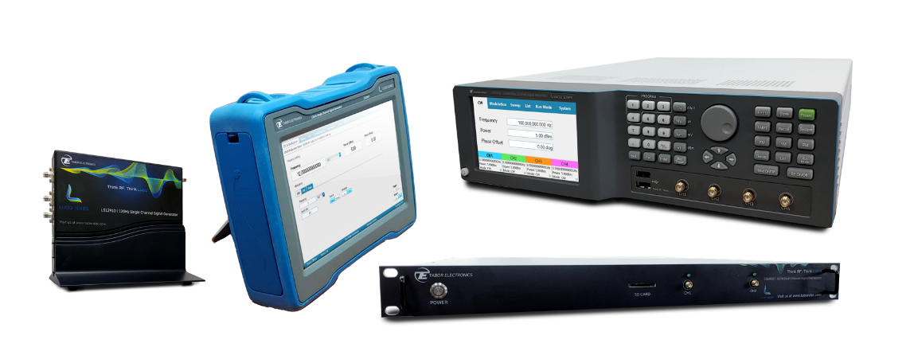
Nesher, August 2020 – Tabor Electronics continues the introduction of its new RF product line with the launch of new platforms to the Lucid Series Signal Generator. As all Tabor products, the new series is designed to offer industry leading price to performance ratio. The Lucid series will enable Tabor to offer a full product portfolio for generating signals for various applications whether, 5G, radar, communications and more.

Tabor’s Lucid series includes 4 platforms: Desktop, Benchtop, Rackmount and Portable featuring 3, 6 and 12GHz, all sharing the very same industry leading highlighted features. The line was designed to meet today’s most demanding specifications, needed from the R&D and lab benches to the test automation and production lines.
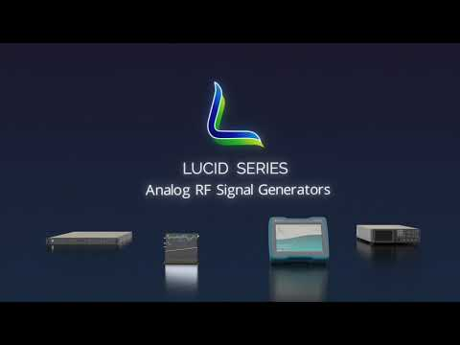
Leading Features:
- Multiple platforms: Desktop, Benchtop, Rackmount and Portable
- 100kHz to 3, 6 or 12GHz
- Fast switching time of less than 100µs
  - Extremely low SSB phase noise of -138dBc/Hz at 1GHz (< -118dBc/Hz at 12GHz) and 10 kHz carrier offset
  - AM, FM, PM, Sweep & Pulse modulation
  - SPI and micro-USB interfaces
  - Extra small, compact module platform
  - Remotely programmable via Tabor’s dedicated GUI, MATLAB, Python, LabVIEW or any other software programming environments
  - Excellent customer and technical support with the ability and (desire) to customize instruments to specific customer demands

Jonathan Netzer Tabor’s product director commented: “We're proud to expand the new Lucid series and to provide engineers with a full feature alternative for their RF signal generation needs. The Lucid series demonstrates once again Tabor’s ability to offer industry leading performance while saving engineers both very valuable space and investment capital.”
Ron Glazer, Tabor CEO added: “The full product line is just a first glimpse of the future products that our new RF division is working on. These new capabilities enable us not only to expand the Tabor product portfolio, but also to offer a wider range of solutions to our current and potential OEM customers that are looking to use and/or embed our capabilities into their platforms.”

About Tabor Electronics
Established in 1971, Tabor Electronics has become a world-leading provider of high-end signal sources, featuring: RF, pulse, function and arbitrary waveform generators/transceivers, high-voltage amplifiers, waveform and modulation creation software. Tabor has earned global recognition for its highly skilled workforce and innovative engineering capabilities. In addition to offering a full range of self-branded instruments, Tabor is also a world-class OEM that private-labels a variety of products for industry leaders. Technologically advanced, featuring the highest levels of performance, reliability, and most importantly, price-competitive, Tabor’s products are sought-after in a diverse array of applications.

For additional information contact:
Rotem Koren, Marketing Communication Manager
rotem.k@tabor.co.il | + 972 52 4593508
Tabor Electronics | www.taborelec.com

